Source Analysis Practice

Source 1
Cover image from Andrew Hamiltons article “Theres more to identity than flag-waving’ from Eureka Street (2014)


Source 2
Image generated from Shutterstock (2022) showing the traditional symbols of Australian culture and nature in the form of a map.

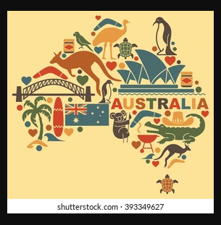

Source 3
Visual depiction of the World War 1 soldier from the Australian Imperial Force (2015).
